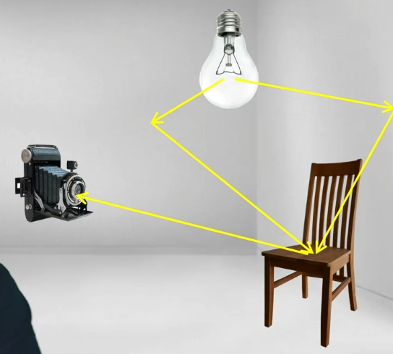

Ray tracing, where each 2D image is generated by tracing back the path of light from our eyes which is represented by a virtual camera. Then we go through the middle of each pixel on the display. Rasterization can be considered as an object order algorithm for rendering where we iterate over each object in the scene and consider how each vertex contributes to each pixels. This method is very efficient when there are fewer geometric primitives than the amount of pixels. It has been used in real-time graphics such as games and VR. Ray tracing, on the other hand, is an image order algorithm where we iterate over each pixel on the display and trace back the path of lighting. Typically, it produces more realistic images than rasterization, but at a greater computational cost.

When eye precision is fixed at point P on a mirror surface, I can only see lights from a certain direction, and let's call this the reflection ray. This is the base for recursive ray tracing for mirror surfaces.

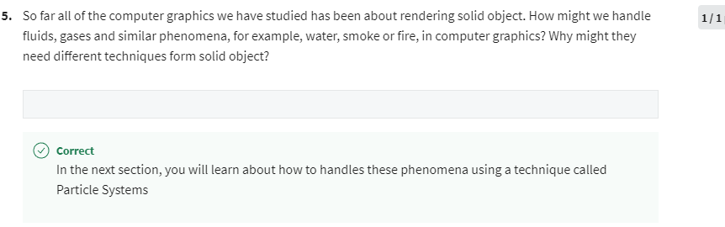

## Particle Systems

